NOTE: This template is shareware downloaded from www.processimpact.com. All shareware payments are donated to the Norm Kerth Benefit Fund to help a consultant who is disabled with a brain injury. Please visit http://www.processimpact.com/norm_kerth.html to make a shareware payment ($10 suggested). Thank you!
Software Requirements Specification
for
Task Hawk
Version 1.0 approved
Samuel Gullett
CS445 Group 4
5May2023
eLearning versions of several popular Process Impact training seminars are available at www.processimpact.com/elearning.shtml, including “In Search of Excellent Requirements,” “Exploring User Requirements with Use Cases,” “Writing High-Quality Requirements,” “Software Inspections and Peer Reviews,” and “Project Management Best Practices”. Single-user and corporate-wide site licenses are both available.
Table of Contents
Table of Contents ii
Revision History ii
1. Introduction 1
1.1 Purpose 1
1.2 Document Conventions 1
1.3 Intended Audience and Reading Suggestions 1
1.4 Project Scope 1
1.5 References 1
2. Overall Description 2
2.1 Product Perspective 2
2.2 Product Features 2
2.3 User Classes and Characteristics 2
2.4 Operating Environment 2
2.5 Design and Implementation Constraints 2
2.6 User Documentation 2
2.7 Assumptions and Dependencies 3
3. System Features 3
3.1 System Feature 1 3
3.2 System Feature 2 (and so on) 4
4. External Interface Requirements 4
4.1 User Interfaces 4
4.2 Hardware Interfaces 4
4.3 Software Interfaces 4
4.4 Communications Interfaces 4
5. Other Nonfunctional Requirements 5
5.1 Performance Requirements 5
5.2 Safety Requirements 5
5.3 Security Requirements 5
5.4 Software Quality Attributes 5
6. Other Requirements 5
Appendix A: Glossary 5
Appendix B: Analysis Models 6
Appendix C: Issues List 6

Revision History
Name | Date | Reason For Changes | Version
Jacob Thieret | 05/07/2023 | Adds additional information to Sam Gullet’s initial documentation.  Adds:  - 2.3 User Classes and Characteristics  - 2.5 User Documentation  Modifies:  - 2.6 Assumptions and Dependencies  - 3.1.2 Stimulus/Response Sequences  - 4.2 Hardware Interfaces  - Appendix C: Issues list | 2.0

Introduction

Purpose
The purpose of this app (Task Hawk v1.0) is to provide a convenient and efficient way for users to view and manage their upcoming tasks and events on a calendar. The app aims to improve productivity and organization by allowing users to easily view and prioritize their tasks, set reminders, and track their progress. The app is designed to be user-friendly and customizable to meet the needs of individuals with varying schedules and lifestyles. Overall, the app aims to simplify the task management process and enhance the user's ability to stay on top of their commitments.

Document Conventions
There are no specific standards or typographical conventions that were followed when writing this SRS. The document has been prepared in a clear and concise manner, with each requirement statement being assigned a unique identifier for easy reference. There are no assumptions made regarding the inheritance of priorities, and each requirement statement has been assigned its own priority level. The document has been formatted using standard fonts and styles for ease of reading and understanding.

Intended Audience and Reading Suggestions
This document is intended for various types of readers, including developers and users. The SRS contains an overview section that provides a high-level summary of the project, including its purpose, goals, and objectives. The functional requirements section describes the specific features and functions that the app must have, including user interface, calendar integration, and task management. The non-functional requirements section describes the performance, usability, and security requirements of the app.

The document is organized in a logical manner that starts with an introduction and overview of the project, followed by a detailed description of the functional and non-functional requirements. The document concludes with appendices that contain additional information, such as glossary of terms and reference materials.

The suggested sequence for reading the document would be as follows:

Introduction and Overall Description- all readers
System Features – all readers
External Interface Requirements - developers
Other Non-functional Requirements - developers
Appendices - developers

Project Scope
This software is a task management application that includes a calendar for recording upcoming tasks. The purpose of the software is to provide users with an easy and efficient way to manage their tasks and keep track of important dates. The benefits of the software include increased productivity, improved time management, and better organization of tasks and events. The objectives of the software are to provide a user-friendly interface, and flexible task management features.

This application can be related to corporate goals and business strategies by enabling employees to be more efficient and productive in their work, leading to increased overall performance and success for the organization. This software can also be used by individuals to help them better manage their personal tasks and responsibilities, leading to improved work-life balance and overall well-being.

References
There are no other documents or web addresses that are referred to in this SRS. All relevant information and requirements have been included within this document.

Overall Description

Product Perspective
This product is a new, self-contained application that allows users to record upcoming tasks. This product is not a replacement for any existing system, nor is it part of a larger product family. It is designed to be a standalone application that can be used by individuals or small teams to manage their schedules and tasks efficiently.

Product Features
This product allows users to record upcoming tasks. The major features of the app include the ability to create and edit tasks, view tasks by day, week, or month, and save tasks to lists. A top-level Class Diagram is provided:

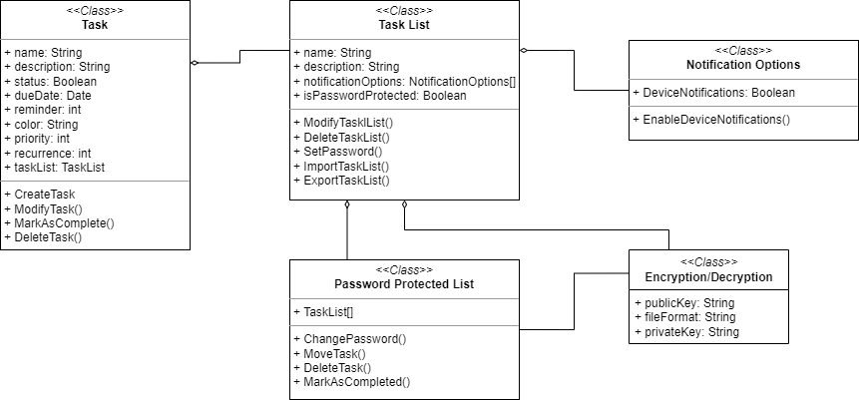

User Classes and Characteristics
<Identify the various user classes that you anticipate will use this product. User classes may be differentiated based on frequency of use, subset of product functions used, technical expertise, security or privilege levels, educational level, or experience. Describe the pertinent characteristics of each user class. Certain requirements may pertain only to certain user classes. Distinguish the favored user classes from those who are less important to satisfy.>

- Casual Users: These users might use the product occasionally to manage their day-to-day tasks. They have basic technical expertise and may only use a subset of the product functions, such as creating tasks, setting reminders, and marking tasks as completed. They might not be interested in advanced features like task categorization or repeating tasks.
  - Frequency of Use: Casual users may not use the product daily or consistently. Instead, they might use it sporadically to manage tasks when needed, like during busy periods or to remember important events.
  - Technical Expertise: Casual users typically have basic technical skills and may not be interested in advanced features or complex functionalities. They prefer an easy-to-use interface and straightforward navigation.
  - Functions Utilized: Casual users generally require essential functions such as creating tasks, setting reminders, and marking tasks as completed. They may not be interested in advanced features like task categorization, filtering, sorting, or integration with other productivity tools.
  - Simplicity: Casual users value simplicity and an intuitive user interface. They might prioritize ease of use over extensive feature sets or customization options.
- Student Users: They use the task management application to manage their academic tasks, assignments, and projects. Key characteristics of student users include:
  - Frequency of Use: The frequency of use may vary depending on the students' workload, study habits, and personal preferences. Some may use the product daily, while others might use it occasionally or during exam periods.
  - Age and Educational Level: Student users can range from elementary school students to postgraduate students, with varying levels of educational experience and technical expertise.
  - Functions Utilized: Student users generally require basic functions like creating tasks, setting deadlines, and marking tasks as completed. They may also need advanced features like reminders, and repeating tasks (e.g., for recurring assignments or study sessions).
  - Accessibility: As students may use the product across various devices (e.g., smartphones, tablets, and laptops), it is crucial to ensure that the task management application is accessible and user-friendly on different platforms. Flutter makes it easy to integrate our application to many platforms.

Operating Environment
This will operate on mobile Android platforms. The app will not have any external dependencies other than the very common Java Runtime Environment and will not require any specific hardware or software components other than those typically found on a mobile system. It is expected to peacefully coexist with any other software applications running on the user's system.
Design and Implementation Constraints
The app is available to IOS and Android applications, however it has only been tested and ran in an Android Emulator. In theory, it should work on IOS as well. It must not interfere with the normal functioning of other applications on the device. This app is designed to work with different screen sizes and orientations. Flutter was used to develop the UI.

Local Storage/State Management solution: The Sqflite package and GetX package are popular libraries in the Flutter ecosystem, used for data storage and state management, respectively. In our application, these packages are employed for handling data storage and retrieval/state management.

- Sqflite Package:
  - Sqflite is a Flutter plugin that provides a SQLite database for storing data locally on the device. SQLite is a lightweight, serverless, and self-contained SQL database engine that is easy to set up and requires minimal configuration. It is an ideal choice for local storage in mobile applications.
    - Local data storage with support for CRUD (Create, Read, Update, and Delete) operations.
    - Transaction support to ensure data integrity during multiple operations.
    - SQL query support for searching, filtering, and sorting data.
    - Easy integration with Flutter applications.

- GetX Package:
  - GetX is a comprehensive state management, dependency injection, and route management solution for Flutter applications. It is known for its simplicity, performance, and minimal boilerplate code.
    - Reactive state management with easy-to-use APIs for observing changes in the data.
    - Dependency injection for providing and managing instances of classes throughout the application.
    - Route management with a simple and powerful API for navigating between screens.
    - Support for internationalization and theming.

In summary, the combination of Sqflite and GetX in our application provides a robust solution for local data storage and state management. Sqflite handles storing and managing data in a SQLite database, while GetX manages the application state and provides an efficient way to access and update the data in the UI.

User Documentation
Title: User Guide for Task Hawk
Introduction: Welcome to the user guide for Task Hawk! This guide will help you understand the various features of our task management application and provide step-by-step instructions to get started. With our application, you can create, edit, and delete tasks, mark tasks as completed, and customize tasks with various attributes. You can also view your tasks in a weekly or monthly view and create task lists.
Getting Started:
- Download and install Task Hawk from the app store on your device.
- Open the application.
Creating a Task:
- To create a new task, tap on the "+" button on the main screen.
- Enter a title and note for your task.
- Optionally, you can customize your task by adding start time, end time, due date, recurrence, reminder, and color. Tap on each field and input the desired information.
- Once you have entered all the task details, tap on the "+" button to add the task to your list.
Editing a Task:
- To edit a task, tap on the task you want to modify from the task list.
- Tap “Edit Task” button in the bottom sheet.
- Update the task details as needed.
- Tap on the "Save" button to save your changes.
Deleting a Task:
- To delete a task, tap and hold on the task you want to remove from the task list.
- A confirmation prompt will appear. Tap on "Delete" to confirm the deletion of the task.
Marking a Task as Completed:
- To mark a task as completed, tap on the checkbox next to the task title in the task list.
Navigating between Weekly and Monthly Views:
- On the main screen, you will find a sliding switch at the top of the screen.
- Slide the switch to "Weekly" to view your tasks in a weekly view, or slide it to "Monthly" to view your tasks in a calendar view.
Navigating between Dates:
- In the weekly view, tap on the date picker at the top of the screen to select a different date.
- In the monthly view, simply tap on the desired day on the calendar to view tasks for that day.
Creating a Task List:
- To create a new task list, tap on the "Menu" icon on the main screen.
- Tap on the "+" button to create a new list.
- Enter a name for your task list and tap on "Save."
Note: Task lists have limited functionality in the current version of the application. You can create and manage task lists, but tasks are not directly linked to specific task lists.

Assumptions and Dependencies
Assumptions:
- Users have a compatible device: The application assumes that users have a device with a supported operating system (iOS or Android) and compatible hardware to run the application smoothly.
- Internet connectivity: The application assumes that users have access to a stable internet connection for activities such as account registration, authentication, data synchronization, and receiving updates.
- Basic technical skills: The application assumes that users have basic technical skills to install, set up, and navigate the application. This includes creating, editing, and managing tasks and task lists.

Dependencies:
- Flutter SDK: The application depends on a specific range of the Flutter SDK ('>=2.19.2 <3.0.0') for compatibility and stability. Changes or updates to the Flutter SDK may impact the functionality of the application and require updates to the codebase.
- Third-party packages: The application depends on various third-party packages, such as 'table_calendar', 'get_storage', 'get', 'intl', 'google_fonts', 'date_picker_timeline', 'flutter_local_notifications', 'flutter_native_timezone', 'sqflite', 'flutter_staggered_animations', 'lite_rolling_switch', 'sliding_switch'. Updates or changes to these packages may impact the application's functionality and require updates or modifications to the codebase.
- Linting and coding practices: The application relies on the 'flutter_lints' package for enforcing coding practices and maintaining code quality. Any changes to the lint rules or coding practices may impact the application's functionality and maintainability.

System Features

System Feature 1
3.1.1 Description and Priority
- Task creation and editing: High priority. Users should be able to create and edit tasks easily and quickly.
- Task list creation and editing: High priority. Users should be able to create and edit task lists easily and quickly.
- Task organization: High priority. Users should be able to group tasks into lists or categories for better organization.
- Calendar view: High priority. Users should be able to view tasks on a calendar to get an overview of their schedule.
- Weekly view: High priority. Users should be able to view tasks on a weekly basis to get a shorter range of their schedule.
- Reminders and notifications: Medium priority. Users should be able to set reminders and receive notifications for upcoming tasks.
3.1.2 Stimulus/Response Sequences
Calendar/Week View Interaction Sequence:
- User is presented with a main screen showing a calendar or week view.
- User selects a day on the calendar or week view.
- System displays any tasks that have been scheduled for that day.
Creating a Task Sequence:
4. User clicks the "Create Task" button.
- System displays a form for creating a new task.
- User enters the task details (title, description, start date, start time, task list, etc.) and clicks the "Save" button.
- System saves the task and adds it to the list for the selected day.
Editing a Task Sequence:
8. User selects a task from the list and clicks the "Edit" button.
- System displays a form for editing the task.
- User makes changes to the task details and clicks the "Save" button.
- System saves the changes to the task.
Deleting a Task Sequence:
12. User selects a task from the list and clicks the "Delete" button.
- System removes the task from the list.
Marking a Task Complete Sequence:
14. User selects a task from the list and clicks the "Mark Complete" button.
- System sets the task to completed.
Creating a Task List Sequence:
16. User clicks the "Create Task List" button.
- System displays a form for creating a new task list.
- User enters the task list details (name, description, etc.) and clicks the "Save" button.
- System saves the task list and adds it to the task list menu.
Selecting a Task List Sequence:
20. User selects a task list from the menu.
- System displays the tasks for the selected task list.
Editing a Task List Sequence:
22. User clicks the "Edit" button next to a task list.
- System displays a form for editing the task list.
- User makes changes to the task list details and clicks the "Save" button.
- System saves the changes to the task list.

3.1.3 Functional Requirements

REQ-1: The user should be able to create a new task by selecting a date on the calendar or week view and clicking the "Add Task" button.
REQ-2: The user should be able to edit an existing task by clicking on the task and selecting the "Edit Task" button.
REQ-3: The system should display a form for the user to enter the task name, description, due date, and priority.
REQ-4: The system should validate that the task name is not blank and the due date is a valid date.
REQ-5: If the user attempts to save a task with an invalid name or due date, the system should display an error message indicating which fields need to be corrected.
REQ-6: When the user saves a new task, the system should add it to the appropriate task list for the selected date and refresh the calendar or week view.
REQ-7: When the user saves changes to an existing task, the system shall update the task details and refresh the calendar or week view.

External Interface Requirements

User Interfaces
The user interface of this app includes a calendar or week view where the user can select a specific day. The user can view, create, and edit tasks, which can be added to task lists. These task lists can also be created and edited by the user.

The user interface was constructed by the standards that were implemented within Flutter. Those standards were in turn derived from the Android environment.

Hardware Interfaces
This app takes advantage of the touch and gesture interfaces provided by the Android operating system. The main interaction between software and hardware is the tap, which is a single tap on the screen that can be used to select a day or task, and other general navigation in the application. The user can also swipe left or right on the calendar page to traverse through the months

Software Interfaces
There are no specific connections between this product and other software components. This app is designed to function as a standalone application without any dependencies on other software. Therefore, no data items or messages are coming into or going out of the system, and no data sharing mechanisms are required.

Communications Interfaces
There are no requirements associated with any communication functions required by this product as there are no communication services used.

Other Nonfunctional Requirements

Performance Requirements
This app has been designed and implemented with efficiency in mind to ensure that it operates smoothly and responsively on the specified hardware platform and operating system. Any future performance requirements will be communicated to the development team in a timely manner and incorporated into the software design and implementation as necessary.

Safety Requirements
This app should not pose any safety hazards to its users. However, it is important to note that the app may be used to schedule important tasks or events, such as medical appointments or deadlines for important projects. Therefore, it is important to ensure that the app is reliable and does not result in loss or harm due to missed appointments or deadlines.

Security Requirements
There are no security or privacy requirements for this product as it does not deal with any sensitive or confidential information. However, if security or privacy concerns arise in the future, appropriate measures should be taken to protect the data and ensure that user identity is authenticated.

Software Quality Attributes
The following quality characteristics are important for the success of this app:
- Usability: The app should be easy to learn and use, with an intuitive interface and clear instructions.
- Reliability: The app should operate reliably without errors and provide consistent results across multiple runs.
- Maintainability: The app should be easy to maintain and update, with well-structured and well-documented code.

Other Requirements
There are no other requirements that are not covered in this document.

Appendix A: Glossary
There are no terms, acronyms, or abbreviations used in this SRS that require definition or clarification.
Appendix B: Analysis Models

Class Diagram:

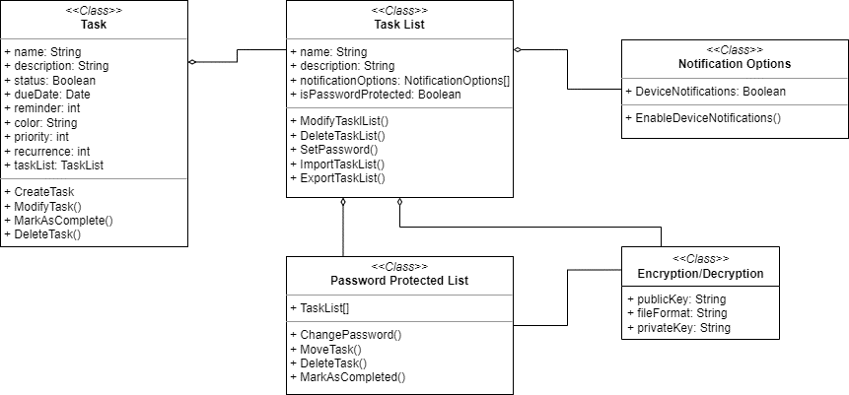

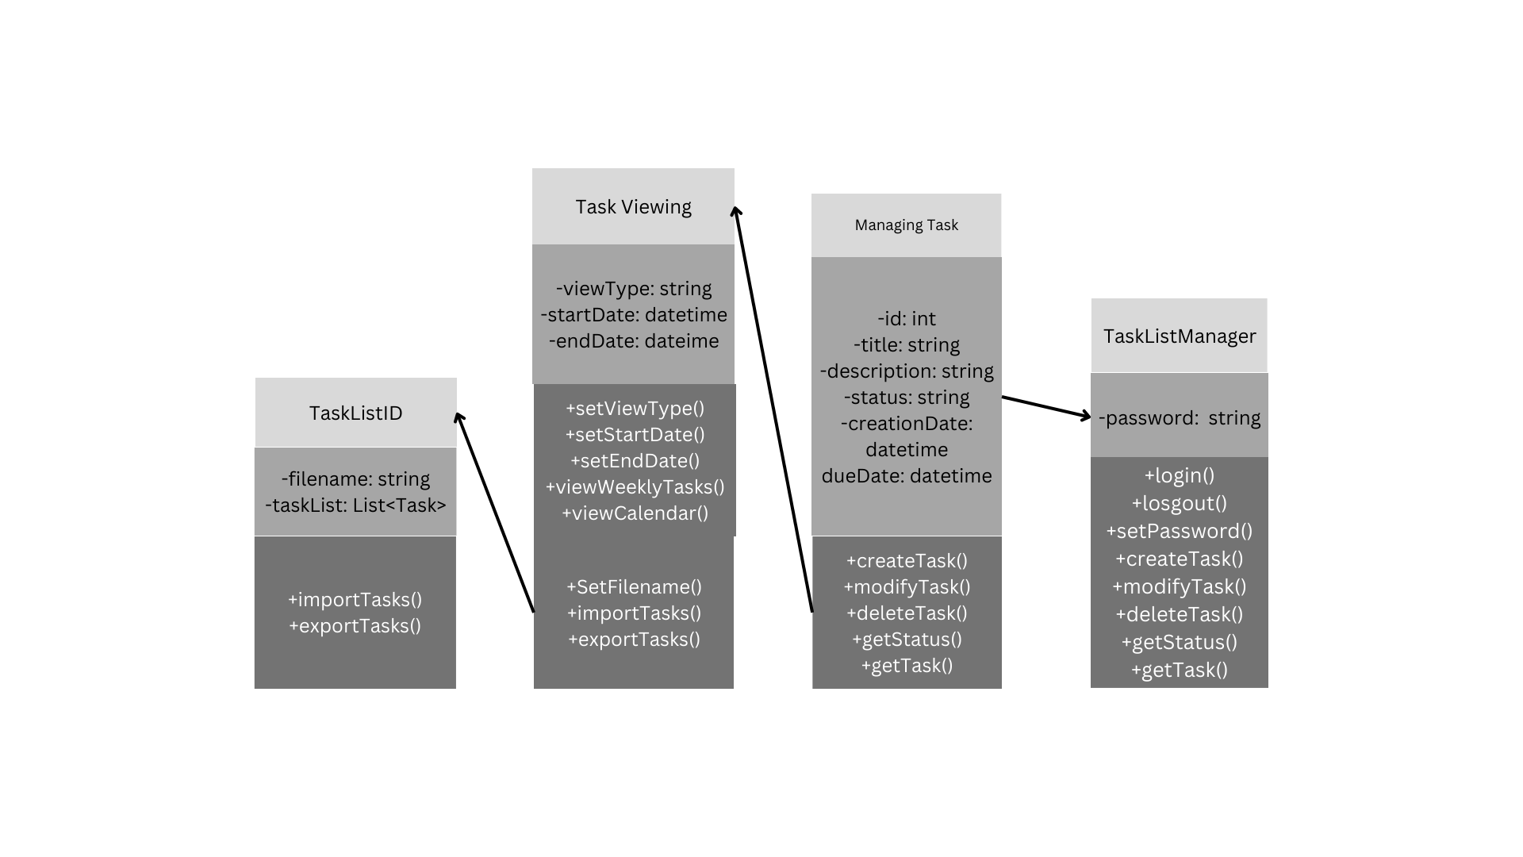

Sequence Diagrams:

Sequence Diagrams:
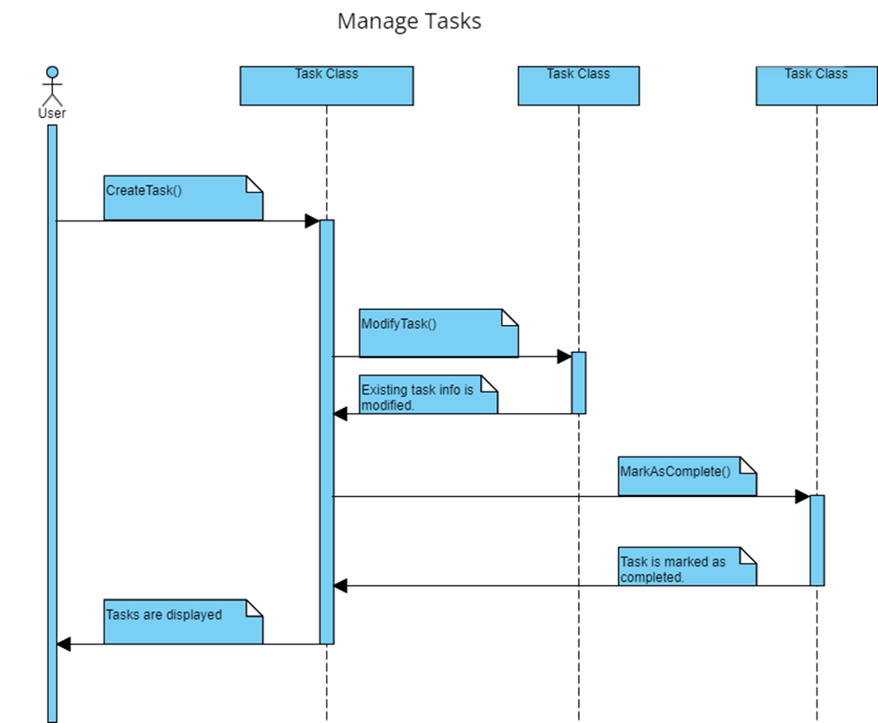

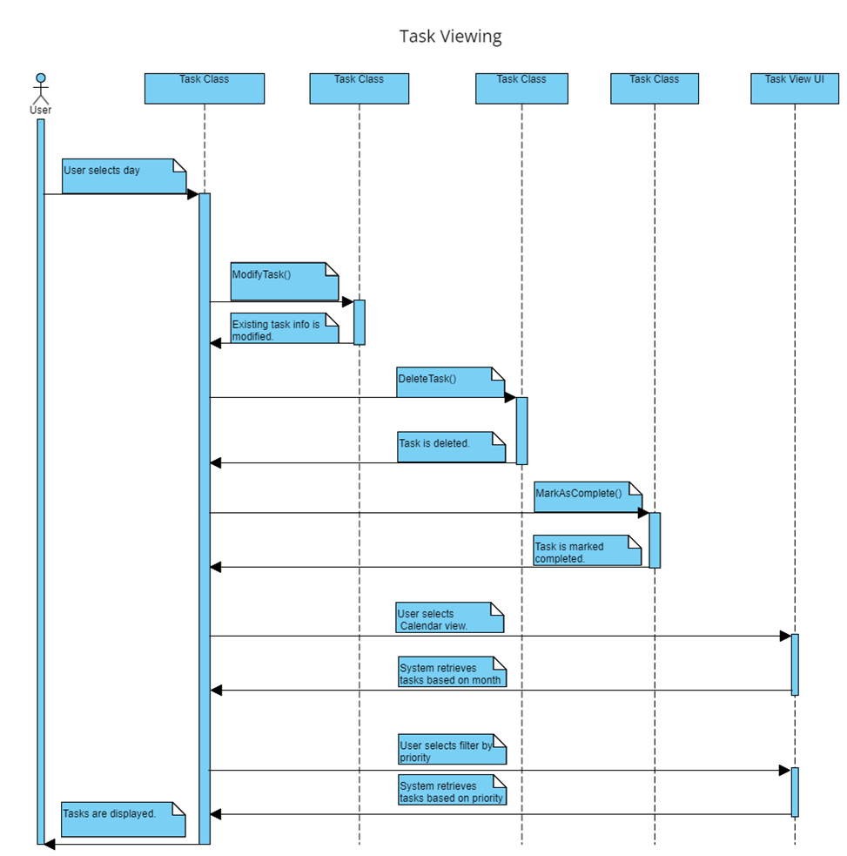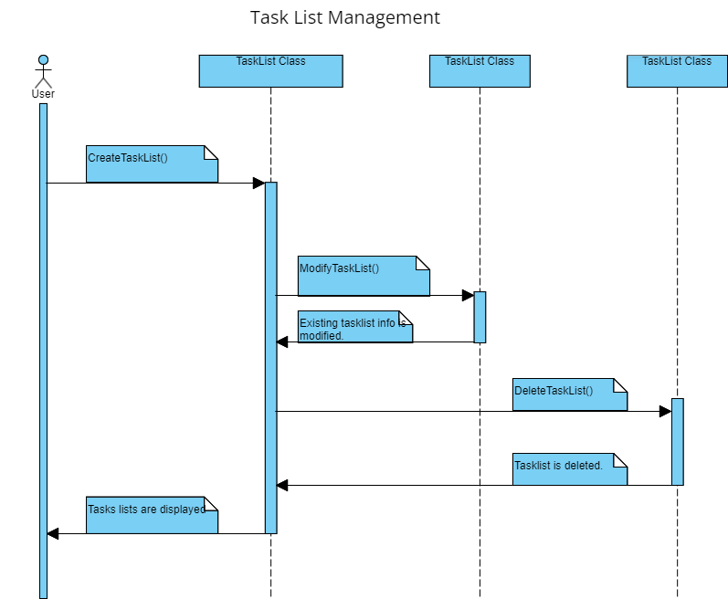
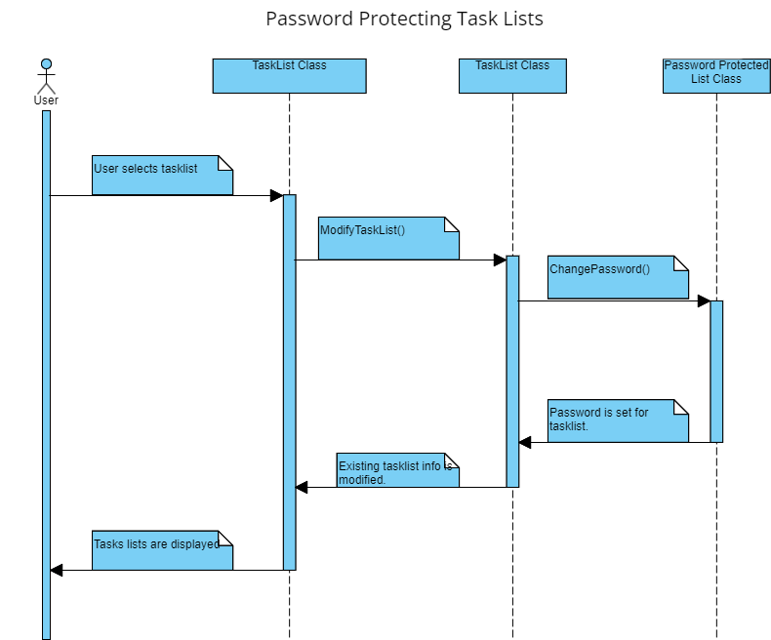

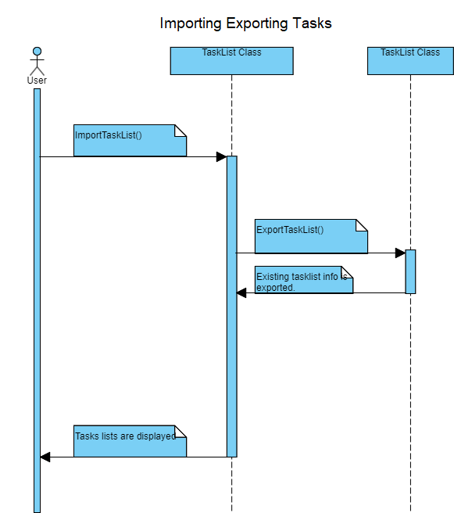
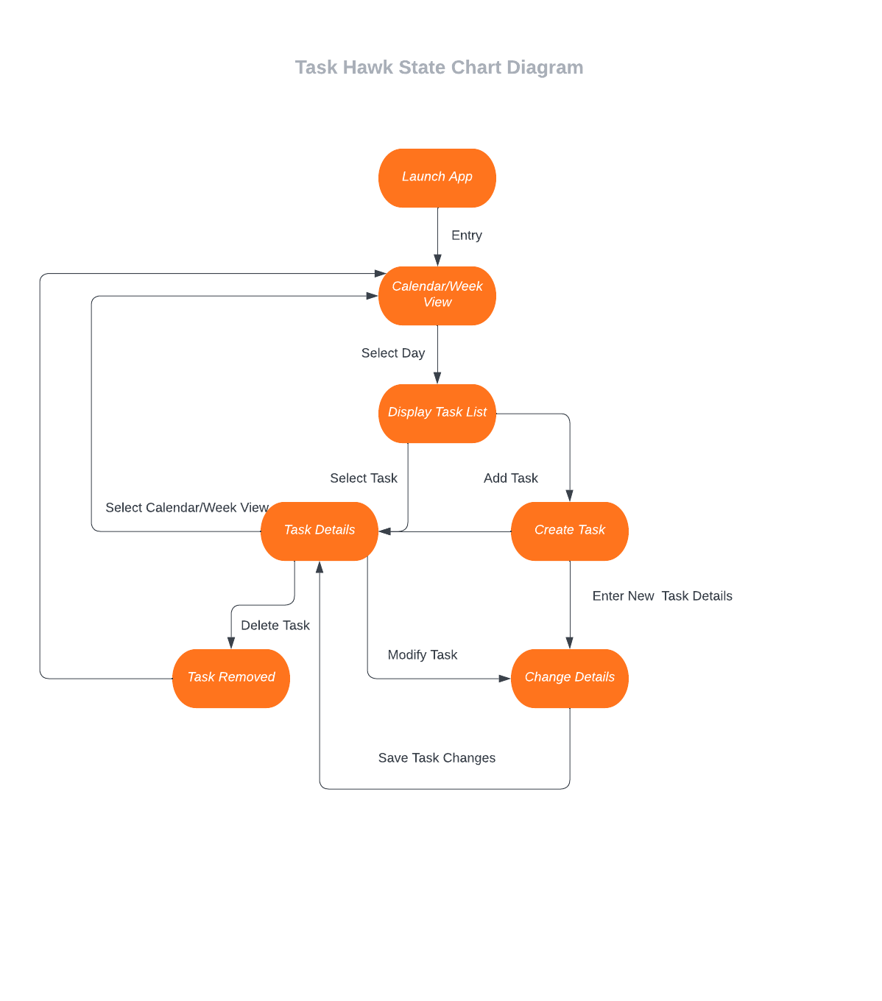
Conceptual Model:
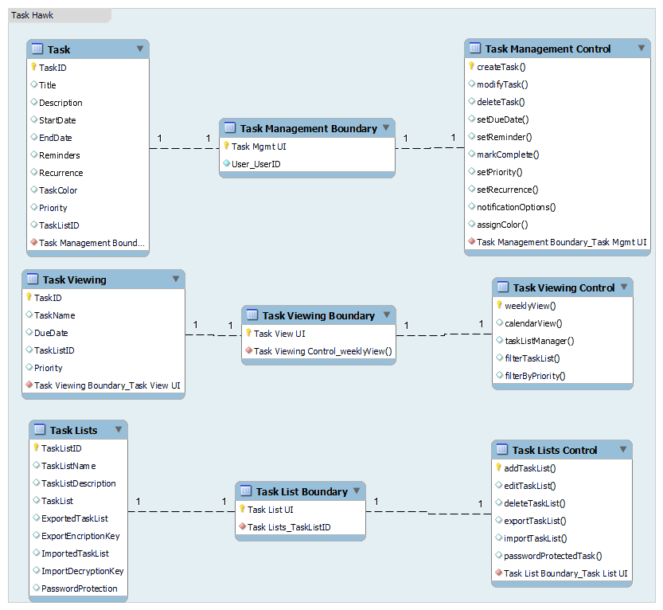
Use Case Diagram:
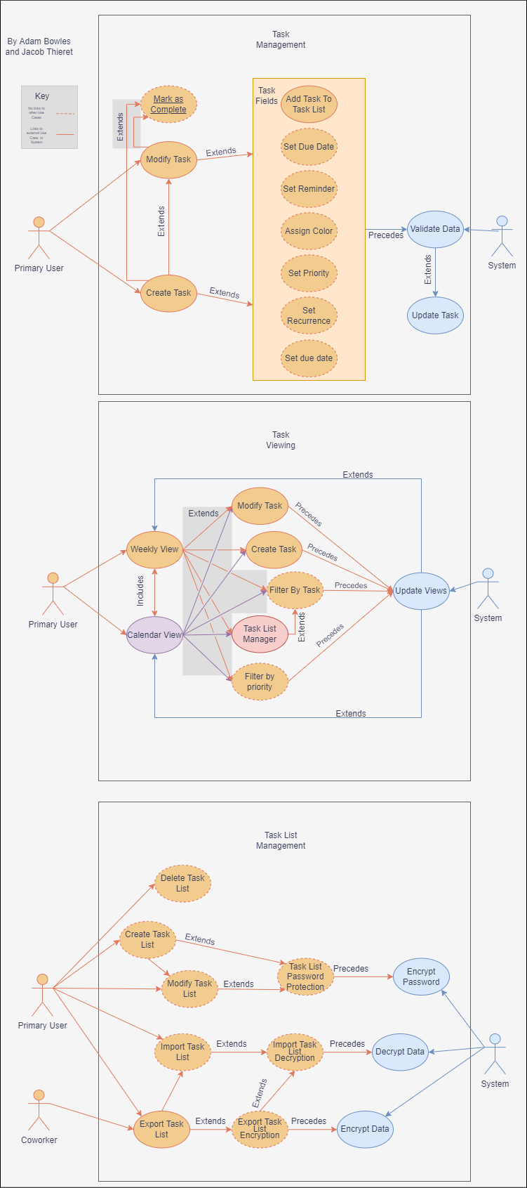

Appendix C: Issues List
- Inadequate error handling: If the application does not handle errors gracefully, it may crash or display unhelpful error messages to the user, leading to a poor user experience.
- Incomplete task list functionality: The current version of the application has limited functionality for task lists. Enhancements or improvements may be necessary to better support task list management.
- Notification and reminder issues: The application uses the 'flutter_local_notifications' package for task reminders. This functionality was not fully tested. If there are any issues with the package or the implementation, users may not receive timely reminders for their tasks.
- Multiple Active Bugs: The current version of the application has multiple bugs. When submitting a task to be created, the end time is not properly set. When deleting a task list, the list does not instantly refresh. When adding a task to a task list, the task list ID value for task is not set.
- Not Fully Tested: The current version of the application has not undergone rigorous testing and quality assurance. Many edge cases are not accounted for, possibly resulting in a poorer user experience. Additionally, the application as only been ran on and Android Emulator

